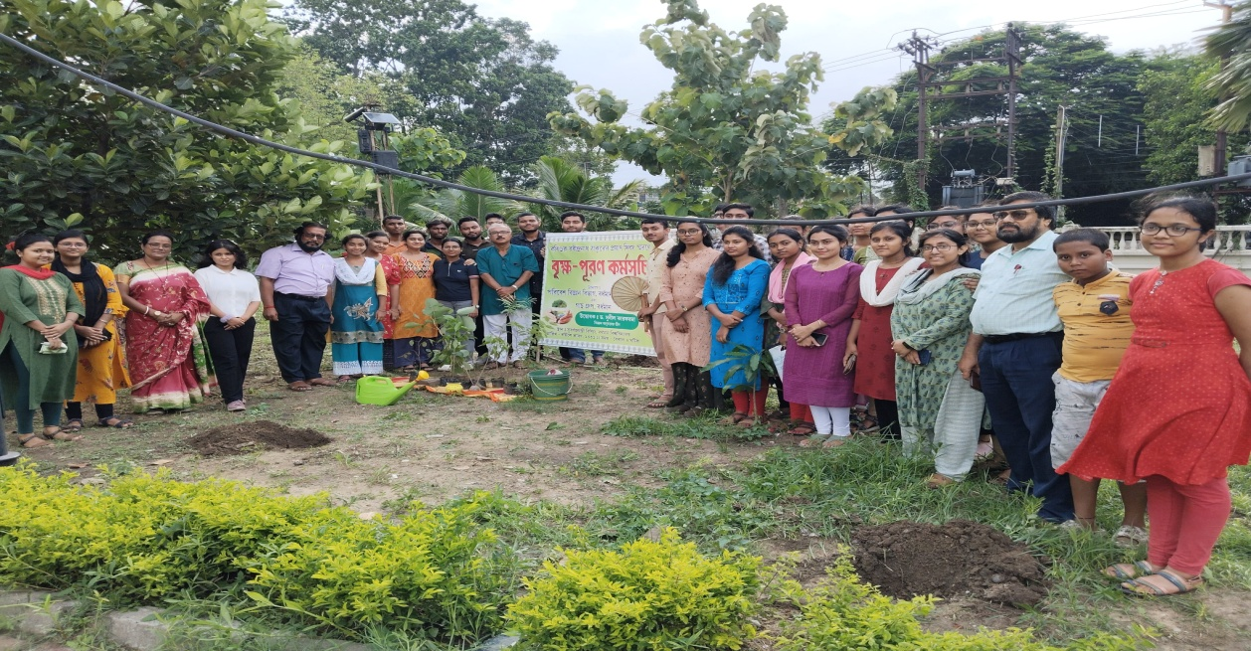
Workshop on Plantation 17.05.2023 Initiated by Gaach Group Briksha-Puran Prorgram

